**DAILY ONLINE ACTIVITIES SUMMARY**

|  |  |  |  |  |  |  |  |  |
| --- | --- | --- | --- | --- | --- | --- | --- | --- |
| **Date:** | **26-06-2020** | | | | | **Name:** | **Anix Jugal D’Cunha** | |
| **Sem & Sec** | **8 sem , A sec** | | | | | **USN:** | **4AL16CS013** | |
| **Online Test Summary** | | | | | | | | |
| **Subject** | | **Test was not conducted Today** | | | | | | |
| **Max. Marks** | | **--** | | **Score** | | | **--** | |
| **Certification Course Summary** | | | | | | | | |
| **Course** | **PHP & MySQL - Certification Course for Beginners** | | | | | | | |
| **Certificate Provider** | | | **Udemy** | | **Duration** | | | **3.5 hours** |
| **Coding Challenges** | | | | | | | | |
| **Problem Statement:** Python Program on How to check if a given number is Fibonacci number | | | | | | | | |
| **Status: Competed** | | | | | | | | |
| **Uploaded the report in Github** | | | | | **yes** | | | |
| **If yes Repository name** | | | | | **alvas-education-foundation/dcunhaanixjugal** | | | |
| **Uploaded the report in slack** | | | | | **yes** | | | |

Online Test Details: (Attach the snapshot and briefly write the report for the same)

Test was not conducted Today

Certification Course Details: (Attach the snapshot and briefly write the report for the same)

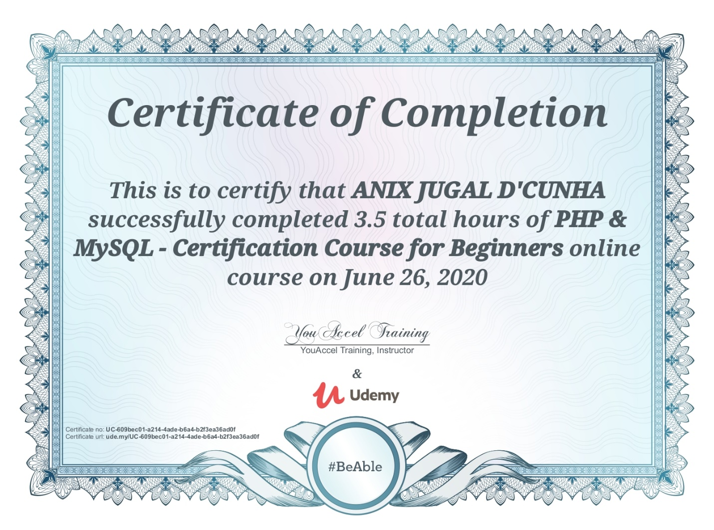

Coding Challenges Details: (Attach the snapshot and briefly write the report for the same)

## Program->Python Program on How to check if a given number is Fibonacci number

## import math

## # A utility function that returns true if x is perfect square

## def isPerfectSquare(x):

## s = int(math.sqrt(x))

## return s*s == x

## 

## # Returns true if n is a Fibinacci Number, else false

## def isFibonacci(n):

## 

## # n is Fibinacci if one of 5*n*n + 4 or 5*n*n - 4 or both

## # is a perferct square

## return isPerfectSquare(5*n*n + 4) or isPerfectSquare(5*n*n - 4)

## 

## # A utility function to test above functions

## for i in range(1,11):

## if (isFibonacci(i) == True):

## print i,"is a Fibonacci Number"

## else:

## print i,"is a not Fibonacci Number "